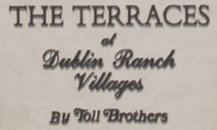

The Terraces Dublin Ranch Villages Market Report for March 2016



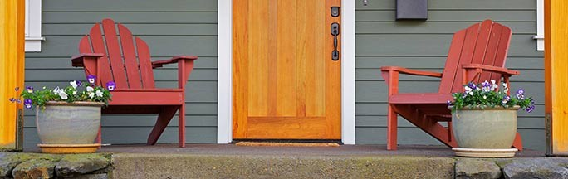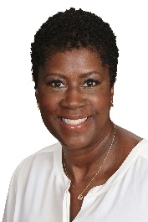

Your Real Estate Update

**Patricia Woods, Coldwell Banker / B R E #: 01310443**21060 Redwood Road Suite 10 0, C a s t r o Valley, CA 94546 (Mobile) 510.754.8145 (work) 510.583.5400 x5450

**Email Me:** [**PatriciaWoods@cbnorcal.com**](mailto:PatriciaWoods@cbnorcal.com)

[**Visit My Website**](https://www.coldwellbankerhomes.com/ca/castro-valley/agent/patricia-woods/aid_150824)**:** [**www.BayEastRealtor.com**](http://www.BayEastRealtor.com)